Date: 30/11/24
Progress:
Curiosity was killing me and I decided to see from where can I begin. So, I considered the function
F(x) = 255 sin(x) where unit of x is radians. I would like to call this the Introductory Experiment.
I found out the values of F(x) from x = 1 till x = 256
Data:

 |  | R | G | B
1 | 214.5751 | 214 | 107 | 53
2 | 231.8708 | 231 | 115 | 57
3 | 35.9856 | 35 | 17 | 8
4 | 192.9846 | 192 | 96 | 48
5 | 244.5257 | 244 | 122 | 61
6 | 71.25095 | 71 | 35 | 17
7 | 167.5316 | 167 | 83 | 41
8 | 252.2864 | 252 | 126 | 63
9 | 105.0902 | 105 | 52 | 26
10 | 138.7254 | 138 | 69 | 34
11 | 254.9975 | 254 | 127 | 63
12 | 136.8261 | 136 | 68 | 34
13 | 107.1426 | 107 | 53 | 26
14 | 252.6049 | 252 | 126 | 63
15 | 165.8234 | 165 | 82 | 41
16 | 73.41535 | 73 | 36 | 18
17 | 245.1564 | 245 | 122 | 61
18 | 191.5017 | 191 | 95 | 47
19 | 38.21869 | 38 | 19 | 9
20 | 232.801 | 232 | 116 | 58
21 | 213.3472 | 213 | 106 | 53
22 | 2.257084 | 2 | 1 | 0
23 | 215.7862 | 215 | 107 | 53
24 | 230.9225 | 230 | 115 | 57
25 | 33.7497 | 33 | 16 | 8
26 | 194.4524 | 194 | 97 | 48
27 | 243.8759 | 243 | 121 | 60
28 | 69.08098 | 69 | 34 | 17
29 | 169.2266 | 169 | 84 | 42
30 | 251.9481 | 251 | 125 | 62
31 | 103.0296 | 103 | 51 | 25
32 | 140.6138 | 140 | 70 | 35
33 | 254.9775 | 254 | 127 | 63
34 | 134.9161 | 134 | 67 | 33
35 | 109.1866 | 109 | 54 | 27
36 | 252.9036 | 252 | 126 | 63
37 | 164.1022 | 164 | 82 | 41
38 | 75.57399 | 75 | 37 | 18
39 | 245.7678 | 245 | 122 | 61
40 | 190.0039 | 190 | 95 | 47
41 | 40.44878 | 40 | 20 | 10
42 | 233.713 | 233 | 116 | 58
43 | 212.1026 | 212 | 106 | 53
44 | 4.513991 | 4 | 2 | 1
45 | 216.9804 | 216 | 108 | 54
46 | 229.956 | 229 | 114 | 57
47 | 31.51115 | 31 | 15 | 7
48 | 195.9049 | 195 | 97 | 48
49 | 243.2069 | 243 | 121 | 60
50 | 66.90559 | 66 | 33 | 16
51 | 170.9084 | 170 | 85 | 42
52 | 251.59 | 251 | 125 | 62
53 | 100.9609 | 100 | 50 | 25
54 | 142.4912 | 142 | 71 | 35
55 | 254.9376 | 254 | 127 | 63
56 | 132.9955 | 132 | 66 | 33
57 | 111.222 | 111 | 55 | 27
58 | 253.1825 | 253 | 126 | 63
59 | 162.3682 | 162 | 81 | 40
60 | 77.72671 | 77 | 38 | 19
61 | 246.36 | 246 | 123 | 61
62 | 188.4911 | 188 | 94 | 47
63 | 42.6757 | 42 | 21 | 10
64 | 234.6066 | 234 | 117 | 58
65 | 210.8413 | 210 | 105 | 52
66 | 6.770544 | 6 | 3 | 1
67 | 218.1576 | 218 | 109 | 54
68 | 228.9716 | 228 | 114 | 57
69 | 29.27013 | 29 | 14 | 7
70 | 197.3421 | 197 | 98 | 49
71 | 242.5189 | 242 | 121 | 60
72 | 64.72496 | 64 | 32 | 16
73 | 172.5768 | 172 | 86 | 43
74 | 251.2123 | 251 | 125 | 62
75 | 98.88432 | 98 | 49 | 24
76 | 144.3574 | 144 | 72 | 36
77 | 254.8776 | 254 | 127 | 63
78 | 131.0645 | 131 | 65 | 32
79 | 113.2487 | 113 | 56 | 28
80 | 253.4416 | 253 | 126 | 63
81 | 160.6214 | 160 | 80 | 40
82 | 79.87334 | 79 | 39 | 19
83 | 246.9329 | 246 | 123 | 61
84 | 186.9635 | 186 | 93 | 46
85 | 44.89928 | 44 | 22 | 11
86 | 235.4819 | 235 | 117 | 58
87 | 209.5635 | 209 | 104 | 52
88 | 9.026567 | 9 | 4 | 2
89 | 219.3177 | 219 | 109 | 54
90 | 227.9691 | 227 | 113 | 56
91 | 27.02682 | 27 | 13 | 6
92 | 198.7638 | 198 | 99 | 49
93 | 241.8119 | 241 | 120 | 60
94 | 62.53926 | 62 | 31 | 15
95 | 174.2317 | 174 | 87 | 43
96 | 250.8149 | 250 | 125 | 62
97 | 96.79997 | 96 | 48 | 24
98 | 146.2124 | 146 | 73 | 36
99 | 254.7977 | 254 | 127 | 63
100 | 129.1232 | 129 | 64 | 32
101 | 115.2666 | 115 | 57 | 28
102 | 253.6808 | 253 | 126 | 63
103 | 158.8621 | 158 | 79 | 39
104 | 82.01371 | 82 | 41 | 20
105 | 247.4865 | 247 | 123 | 61
106 | 185.4213 | 185 | 92 | 46
107 | 47.11934 | 47 | 23 | 11
108 | 236.3387 | 236 | 118 | 59
109 | 208.2694 | 208 | 104 | 52
110 | 11.28188 | 11 | 5 | 2
111 | 220.4606 | 220 | 110 | 55
112 | 226.9489 | 226 | 113 | 56
113 | 24.78139 | 24 | 12 | 6
114 | 200.17 | 200 | 100 | 50
115 | 241.086 | 241 | 120 | 60
116 | 60.34866 | 60 | 30 | 15
117 | 175.873 | 175 | 87 | 43
118 | 250.3978 | 250 | 125 | 62
119 | 94.70805 | 94 | 47 | 23
120 | 148.0559 | 148 | 74 | 37
121 | 254.6979 | 254 | 127 | 63
122 | 127.1719 | 127 | 63 | 31
123 | 117.2754 | 117 | 58 | 29
124 | 253.9002 | 253 | 126 | 63
125 | 157.0903 | 157 | 78 | 39
126 | 84.14766 | 84 | 42 | 21
127 | 248.0207 | 248 | 124 | 62
128 | 183.8646 | 183 | 91 | 45
129 | 49.33571 | 49 | 24 | 12
130 | 237.177 | 237 | 118 | 59
131 | 206.9589 | 206 | 103 | 51
132 | 13.53631 | 13 | 6 | 3
133 | 221.5863 | 221 | 110 | 55
134 | 225.9108 | 225 | 112 | 56
135 | 22.53401 | 22 | 11 | 5
136 | 201.5605 | 201 | 100 | 50
137 | 240.3412 | 240 | 120 | 60
138 | 58.15333 | 58 | 29 | 14
139 | 177.5004 | 177 | 88 | 44
140 | 249.9611 | 249 | 124 | 62
141 | 92.6087 | 92 | 46 | 23
142 | 149.8877 | 149 | 74 | 37
143 | 254.5781 | 254 | 127 | 63
144 | 125.2105 | 125 | 62 | 31
145 | 119.275 | 119 | 59 | 29
146 | 254.0996 | 254 | 127 | 63
147 | 155.3062 | 155 | 77 | 38
148 | 86.27502 | 86 | 43 | 21
149 | 248.5354 | 248 | 124 | 62
150 | 182.2935 | 182 | 91 | 45
151 | 51.54822 | 51 | 25 | 12
152 | 237.9967 | 237 | 118 | 59
153 | 205.6321 | 205 | 102 | 51
154 | 15.78969 | 15 | 7 | 3
155 | 222.6946 | 222 | 111 | 55
156 | 224.8551 | 224 | 112 | 56
157 | 20.28488 | 20 | 10 | 5
158 | 202.9351 | 202 | 101 | 50
159 | 239.5775 | 239 | 119 | 59
160 | 55.95344 | 55 | 27 | 13
161 | 179.114 | 179 | 89 | 44
162 | 249.5048 | 249 | 124 | 62
163 | 90.50209 | 90 | 45 | 22
164 | 151.7079 | 151 | 75 | 37
165 | 254.4383 | 254 | 127 | 63
166 | 123.2393 | 123 | 61 | 30
167 | 121.2653 | 121 | 60 | 30
168 | 254.2792 | 254 | 127 | 63
169 | 153.51 | 153 | 76 | 38
170 | 88.39561 | 88 | 44 | 22
171 | 249.0307 | 249 | 124 | 62
172 | 180.7081 | 180 | 90 | 45
173 | 53.75669 | 53 | 26 | 13
174 | 238.7978 | 238 | 119 | 59
175 | 204.2893 | 204 | 102 | 51
176 | 18.04182 | 18 | 9 | 4
177 | 223.7854 | 223 | 111 | 55
178 | 223.7817 | 223 | 111 | 55
179 | 18.03415 | 18 | 9 | 4
180 | 204.2939 | 204 | 102 | 51
181 | 238.7951 | 238 | 119 | 59
182 | 53.74917 | 53 | 26 | 13
183 | 180.7135 | 180 | 90 | 45
184 | 249.029 | 249 | 124 | 62
185 | 88.3884 | 88 | 44 | 22
186 | 153.5161 | 153 | 76 | 38
187 | 254.2786 | 254 | 127 | 63
188 | 121.2585 | 121 | 60 | 30
189 | 123.2461 | 123 | 61 | 30
190 | 254.4388 | 254 | 127 | 63
191 | 151.7017 | 151 | 75 | 37
192 | 90.50928 | 90 | 45 | 22
193 | 249.5064 | 249 | 124 | 62
194 | 179.1085 | 179 | 89 | 44
195 | 55.96094 | 55 | 27 | 13
196 | 239.5802 | 239 | 119 | 59
197 | 202.9305 | 202 | 101 | 50
198 | 20.29254 | 20 | 10 | 5
199 | 224.8587 | 224 | 112 | 56
200 | 222.6908 | 222 | 111 | 55
201 | 15.78201 | 15 | 7 | 3
202 | 205.6367 | 205 | 102 | 51
203 | 237.994 | 237 | 118 | 59
204 | 51.54069 | 51 | 25 | 12
205 | 182.2989 | 182 | 91 | 45
206 | 248.5337 | 248 | 124 | 62
207 | 86.26778 | 86 | 43 | 21
208 | 155.3123 | 155 | 77 | 38
209 | 254.099 | 254 | 127 | 63
210 | 119.2682 | 119 | 59 | 29
211 | 125.2172 | 125 | 62 | 31
212 | 254.5785 | 254 | 127 | 63
213 | 149.8815 | 149 | 74 | 37
214 | 92.61586 | 92 | 46 | 23
215 | 249.9626 | 249 | 124 | 62
216 | 177.4949 | 177 | 88 | 44
217 | 58.16081 | 58 | 29 | 14
218 | 240.3438 | 240 | 120 | 60
219 | 201.5558 | 201 | 100 | 50
220 | 22.54167 | 22 | 11 | 5
221 | 225.9144 | 225 | 112 | 56
222 | 221.5825 | 221 | 110 | 55
223 | 13.52864 | 13 | 6 | 3
224 | 206.9634 | 206 | 103 | 51
225 | 237.1742 | 237 | 118 | 59
226 | 49.32817 | 49 | 24 | 12
227 | 183.8699 | 183 | 91 | 45
228 | 248.0189 | 248 | 124 | 62
229 | 84.1404 | 84 | 42 | 21
230 | 157.0964 | 157 | 78 | 39
231 | 253.8995 | 253 | 126 | 63
232 | 117.2686 | 117 | 58 | 29
233 | 127.1785 | 127 | 63 | 31
234 | 254.6983 | 254 | 127 | 63
235 | 148.0496 | 148 | 74 | 37
236 | 94.71518 | 94 | 47 | 23
237 | 250.3993 | 250 | 125 | 62
238 | 175.8674 | 175 | 87 | 43
239 | 60.35612 | 60 | 30 | 15
240 | 241.0885 | 241 | 120 | 60
241 | 200.1652 | 200 | 100 | 50
242 | 24.78904 | 24 | 12 | 6
243 | 226.9524 | 226 | 113 | 56
244 | 220.4568 | 220 | 110 | 55
245 | 11.2742 | 11 | 5 | 2
246 | 208.2738 | 208 | 104 | 52
247 | 236.3358 | 236 | 118 | 59
248 | 47.11179 | 47 | 23 | 11
249 | 185.4266 | 185 | 92 | 46
250 | 247.4846 | 247 | 123 | 61
251 | 82.00643 | 82 | 41 | 20
252 | 158.8681 | 158 | 79 | 39
253 | 253.6801 | 253 | 126 | 63
254 | 115.2597 | 115 | 57 | 28
255 | 129.1299 | 129 | 64 | 32
256 | 254.798 | 254 | 127 | 63

Formula used to calculate R,G and B:
R = floor(F(x)).
G = floor(F(x)/2).
B = floor(F(x)/4).

A python script was used to plot the grid:
import matplotlib.pyplot as plt
import matplotlib.patches as patches
from PIL import Image
import numpy as np

def create_color_grid(rgb_values):
"""
Creates a 16x16 grid of colored boxes based on RGB values.

Args:
rgb_values: A list of 256 RGB tuples, each tuple representing (R, G, B) values (0-255).

Returns:
A matplotlib figure object displaying the color grid.
"""

if len(rgb_values) != 256:
raise ValueError("Exactly 256 RGB values are required.")

# Create a figure and axes
fig, ax = plt.subplots(figsize=(8, 8)) # Adjust figure size if needed

# Set axis limits and remove ticks and labels
ax.set_xlim(0, 16)
ax.set_ylim(0, 16)
ax.set_xticks([])
ax.set_yticks([])

# Iterate through RGB values and create boxes
for i in range(16):
for j in range(16):
index = i * 16 + j
color = rgb_values[index] # Assuming rgb_values contains 256 entries

# Create a rectangle patch with the specified color
rect = patches.Rectangle((j, 15-i), 1, 1, linewidth=0, facecolor=tuple(np.array(color)/255))

# Add the rectangle patch to the axes
ax.add_patch(rect)

# Display the grid
plt.show()

return fig
rgbValues = [#list of tuples of above listed RGB values]
create_color_grid(rgbValues)

Obtained Result:
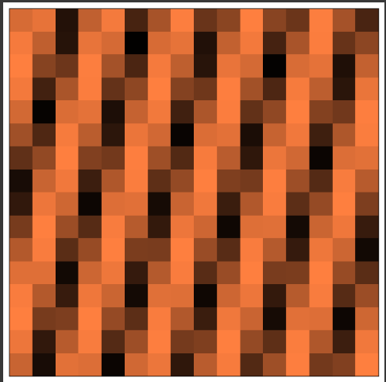
Fig. 1
On exchanging R and G values, obtained resut:
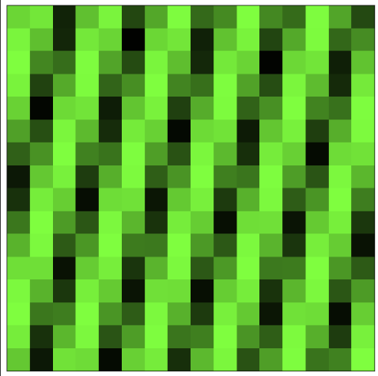
Fig. 2
On assigning
Existing R values to B
Existing G values to R
And Existing B values to G, obtained result:

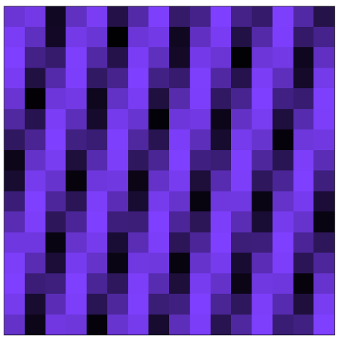
Fig. 3
Analysis of Result:
- Clearly, we can see periodicity in the image produced. This is expected as our original sound signal, F(x), is also periodic.
- The dark patches indicate comparatively low values of R, G and B.
- We can see R dominating in Fig. 1, G dominating in Fig 2, and B dominating in Fig 3, that resonates with the corresponding data.

